Hi Thad,
I appreciate hearing from you as we look to analyze our team and find areas of improvement heading into Spring Training for the 2024 season. Looking forward to a Playoff season from the team this year.
Getting into the Analytics of it all, let’s check out the Pythagorean Formula for Winning Percentage:
$Wpct=\frac{{R_{S}}^{x}}{{R_{S}}^{x}+{R_{A}}^{x}}$ (1)
where we have $Wpct$ represents win percentage, $R_{S}$ represents runs scored, and $R_{A}$ represents runs allowed. With this formula, we can manipulate $x$ to find the best fit based on minimizing the error.
To find the exponent, we can pull the data the Lahman package within R¹ which has a ton of data on baseball teams from 1871 to 2022, for example number of games, Division/Wild Card/League winner (Y/N), strikeouts, etc. For the purpose of recency, we’ll go with the last 10 years, 2013-2022. From there we grab the relevant columns: "teamID", "yearID", "lgID", "G", "W", "L", "R", "RA". Then we look for the variables we need, like Run Differential (Runs minus Runs Against) and Win percentage (Wins divided by Games). Taking a first look with a linear regression:
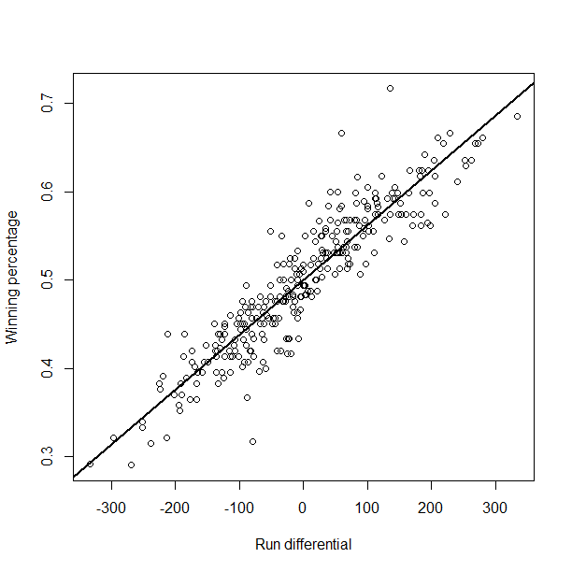
Figure 1. Run Differential vs Winning Percentage 2013-2022. Intercept 0.5, Slope 0.0006189.
We see a positive relationship, with significantly different scales of course, between run differential and win percentage. This makes sense, as over a whole season if you score 1000 more runs than your opponents, one would assume it difficult to make that happen without a winning season. Based on the linear regression’s slope though, we can see the win% change with 1%/162games = 0.006173%/game, indicating that one more win will add 0.006173 to the win%. Based on our slope, that means each 10 in the run differential increases one more game in the win%. While it’s tempting to follow through on the Moneyball aspect in search of those 10 runs, we can discuss that later on. Checking into the teams that have done better/worse overall, let’s take a peek at the teams that have exceeded expectations or fallen short based on this regression:
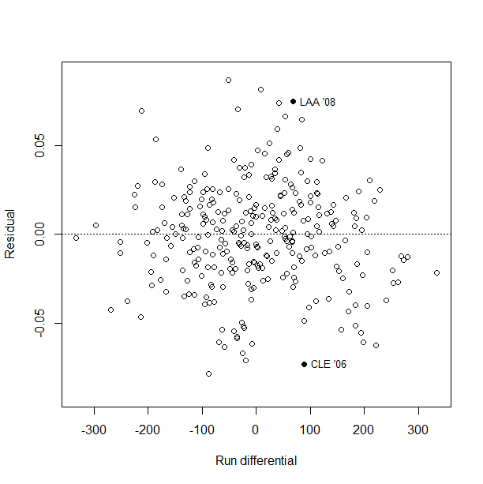
Figure 2. Run Differential vs Residuals, 2013-2022 with horizontal line at expected value.
A couple interesting contextual teams are plotted as well, with the LA Angels (went 100-62 with a Pythagorean predicted 88-74, 765 Runs, 697 Runs Allowed²) and Cleveland Indians (went 78-84 with a Pythagorean predicted 89-73, 870 Runs, 782 Runs Allowed³). Limiting to a subset of just the Twins for the last 10 years with those same contextual points kept,
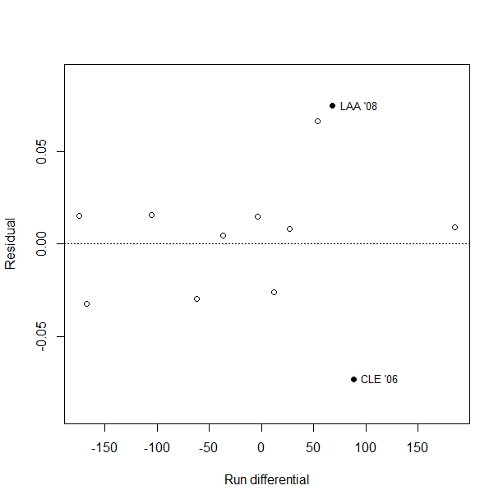
Figure 3. Twins Run Differential vs win% Residual, 2013-2022.
Notably, we’ve been getting more wins than expected, especially with those three points below the expected being 2014, 2016, and 2022. Looking at 2023 from Stathead⁴, we ended at 87-75, with 778 runs scored and 659 scored against, with a win% of 0.537. Per the Pythagorean, $\frac{{778}^{2}}{{778}^{2}+{659}^{2}}= 0.582$. Essentially, we lost a more of the games than we should have (7.2games less, should have won about 94games) based on the 2 in the exponent, whereas we can try to find our own based on the last 10 years by altering equation 1,
$\log\left(\frac{W}{L}\right)=x*\log\left(\frac{R}{RA}\right)$ (2)
Using another linear regression with the information from the last 10 years we actually see the value of $x$ being closer to 1.77. From that perspective, our expected comes out to $\frac{{778}^{1.77}}{{778}^{1.77}+{659}^{1.77}}= 0.573$. While it’s a bit closer, it still indicates we underperformed this year from this simplistic viewpoint.
Looking at a couple counts of the teams in our Division/League from the last 10 years, Detroit (DET) has had 8, Cleveland (CLE) had 5, Kansas City (KCA) had 6, and Chicago (CHA) had 6. Relative to the rest of the AL, out of the 150 seasons, 77 of them were above expected, a 0.513 win%, so on average our division is doing well compared to the league outside of Cleveland at about average.
Moving on to the 2nd part of your request, for our top players, our top 3 batters in At Bats this year were Carlos Correa (514), Max Kepler(438), and Donovan Solano (394) per Stathead⁴. Compared to the rest of the league, they rank 79th, 119th, and tied for 170th. As a quick thought that means our top batters, whether by injury or lack of ability to get through the batting order as many times, we aren’t getting nearly as many at-bats as other teams. In fact we ranked 19th of 30 in at-bats this year.
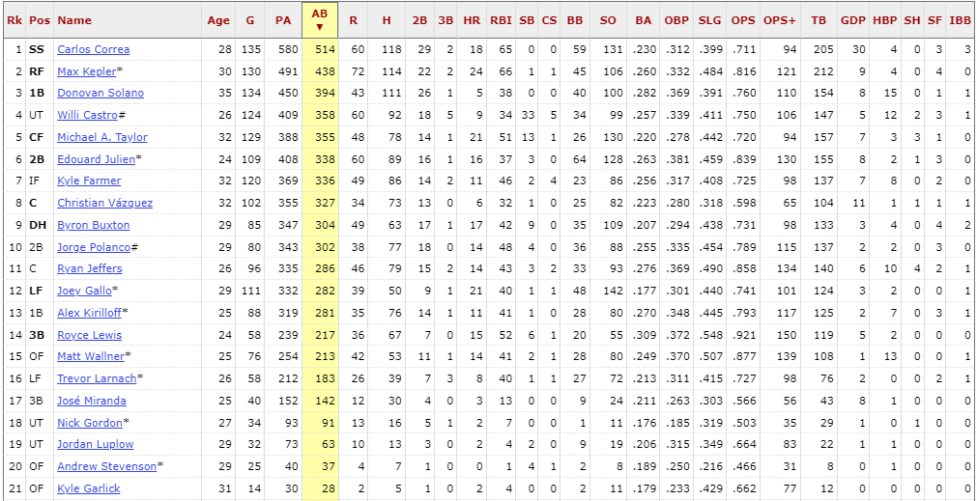
Figure 4. Twins Players ranked by AB, where player had at least 1 at bat.
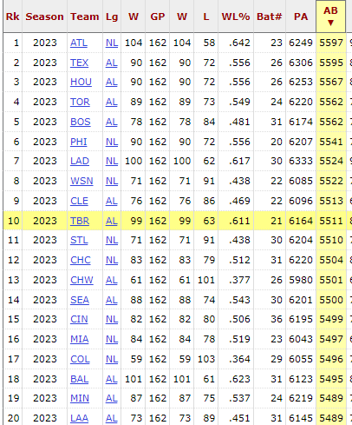
Figure 5. MLB teams ranked by 2023 At-Bats
One metric for seasonal data that’s become popular lately is WAR (Wins Above Replacement), calculated as “(The number of runs above average a player is worth in his batting, baserunning and fielding + adjustment for position + adjustment for league + the number of runs provided by a replacement-level player) / runs per win”⁵. As noted on the site, it describes the player’s value in terms of wins which is useful over the season especially compared to others in the same position. Additionally it considers many factors in its calculation, not just one statistic like Strikeouts, Doubles, etc.
For players that logged in as Shortstop, Correa ranks 4th on our team and 41st in the MLB this year at 1.4WAR, so about a game and a half improvement over any given replacement. Our best to play Shortstop was Willi Castro at 2.7WAR. For Right Fielders, Max Kepler ranks 18th in the league at 2.9WAR, and best for our team. Finally at First Base, Edouard Julien clocks in 2.6WAR at 22nd in the MLB, best for our team, whereas Donovan Solano sits at 44th in the MLB and 3rd for our team at 1.7WAR.
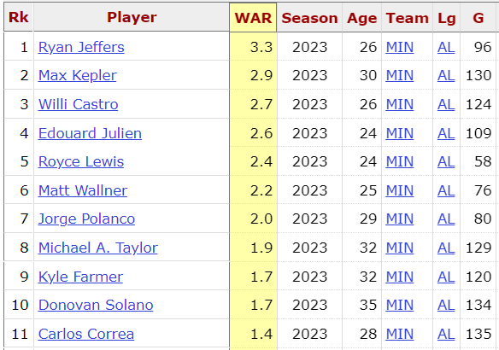
Figure 6. Top 11 rows of Twins 2023 Wins Above Replacement
In terms of pitch-by-pitch, one facet I decided to explore is the “Swung at 1st Pitch” versus “Took 1st Pitch”. Of our players this season with at least 1 at bat, based on Batting Average, 8 of 21 had a better batting average when they took the 1st pitch.
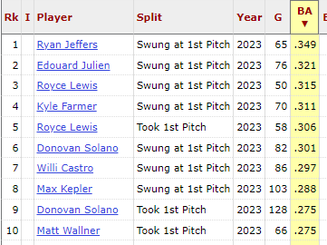
Figure 7. Top 10 rows of Twins 2023 Batting Average Split by “Took 1st Pitch” vs “Swung at 1st Pitch”
By some quick hand calculations, the difference in BA for those who Swung First increased by 0.047 by doing so, and those with a better BA in Took 1st ended up with a 0.052 increase. Specifically for our top-3, Correa was 0.233BA Took and 0.221BA Swung, Kepler was 0.288BA Swung and 0.244BA Took, while Solano was 0.301BA Swung and 0.275BA Took.
I recall a time around midseason the players had a Players Only meeting, where the message coming out of the meeting was to play smarter, not harder. Essentially the Twins were aiming to play less desperation “we have to make something happen, keep swinging” to instead let the game come to them, forcing the pitcher to pitch to the zone as they would no longer be chasing. It seems to have worked, with that slight better increase in taking pitches, and this article describing the difference in wRC+ (weighted Runs Created+) in the month after the meeting being better than the time beforehand⁶. Looking at the same Took/Swung 1st Pitch split ordering by Stathead’s Runs Created, we can see a stark difference for the split:
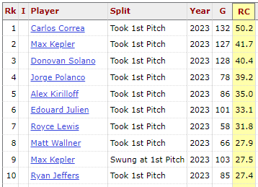
Figure 8. Top 10 rows of Twins 2023 Runs Created Split by “Took 1st Pitch” vs “Swung at 1st Pitch”
With some more hand calculations, ALL of the players created more runs when taking the first pitch as opposed to swinging. The team’s average was 12.73RC better when taking, and for our top-3 Correa was 50.2RC Took and 13.2RC Swung, Kepler was 41.7RC Took and 27.5 RC Swung, and Solano had 40.4RC Took and 13.1RC Swung. Relatively unsurprisingly as they’re the top AB for our team, they were also the top 4 in RC with this split method along with Edouard Julien. Comparing to the rest of the MLB, Correa was 30th for Shortstops, Kepler was 30th for Right Fielders, and Solano was 48th for First Basemen.
Looking into a play-by-play metric, I like Base-Out Runs Added (RE24) to analyze a player’s ability in relation to the state of play, and that it might be harder to create runs with bases empty and 2 outs than 0 outs and bases loaded. With a 0 score for an average player, we can see quickly who does well and who doesn’t based on the situation they’re in for the plate appearance. We see the top of the list has Acuña, Freeman, and Olson, big names so good to have that sanity check. For the Twins, we had Wallner at 17.87 (MLB 47th) which is top of our list, and for our AB leaders: Correa at -22.17 (Shortstop 138th, MLB 650th), Kepler at 10.82 (RF 27th, MLB 82nd), and Solano at 8.90 (1B 31st, MLB 98th). As a note, there are only 659 players who received this RE24 score, so Correa was near the bottom, likely due to the league-leading 30 Grounded Into Double Plays. As a fan it was Correa hit as many GIDPs as he did whenever that was a possibility, while on the other end for Royce Lewis I just found that out of his 12PA with bases loaded last year he hit 4 Grand Slams, 33%, which would be a good batting average on its own.
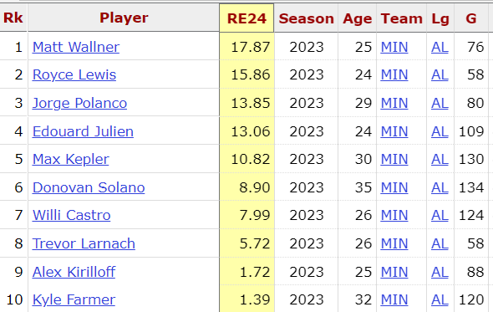
Figure 9. Top 10 rows of Twins 2023 Base-Out Runs Added (RE24)
Overall I’d say we were lacking a bit in getting production regardless of the situation. We of course need to focus on scoring runs and reducing runs allowed, but at least on the offensive side it seems we need to increase the overall production, turning over the order more often and churning out worthwhile ABs. I expect we can play around with the batting order, putting our more prolific hitters earlier to maximize the bases earned and getting them more opportunities. I know we put Correa first up towards the back half of the season to give him some consistency and a higher quantity of PAs, but if he continues underperforming that could be an issue. However, if he’s hitting first up, that’s one less appearance with the potential for a GIDP.
On that note, let’s look at a potential pickup to improve our roster. This is an aspect I’m looking forward to getting more involved with in the team as I’ve not worked with this much before. In looking for a player to consider dropping for the new player, I see Garlick plays outfield for us but in 14 games played only hit 5 times for his 28AB. Essentially, we had a good season and this guy didn’t play as much of a part in it, and his other stats don’t flash as someone to invest too many resources in (0.179 BA, 0.662 OPS). In terms of the stats we looked at earlier, he’s got -0.1 WAR, 0.191 BA Took and 0.143 BA Swung on 1st Pitch, 3 RC, and an RE24 of -0.46. Compared to an average player, this seems replaceable per WAR, RE24, and BA compared to the league average 0.248.
In search of the replacement player, specifically in search of runs, let’s look to RC and RE24 for the overall run creation and contextual runs addition. With a quick search on Sportsrac⁷ and comparing to the top OF in RE24, I see TJ Friedl was higher up on the list, and not a well-known name garnering a giant contract. Specifically, he’s got a 28.25 RE24, and is only under contract for $770k on the Reds (versus 750k for Garlick⁸). For the other relevant stats, he had a 3.8 WAR, 0.299 BA Swung and 0.274 BA Took 1st Swing (0.279 BA overall), and 88 RC.
Clearly, we see the difference between the two players, and at this point the difference is only $20k. For that $20k, we could ostensibly add 3.9WAR (read: add 4 wins), 0.108 BA Took and 0.131 BA Swung 1st Pitch (0.100 BA increase), 85 RC, and 28.71 RE24 with one player swap. Additionally it looks like he had a good year last year, batting 488 ABs with 18HR, 66 RBI, 0GIDP, and earned an NL MVP vote. I’m not sure what all nuances go into the decision and what other factors play in including what an eventual contract would actually be, but this seems like a worthwhile deal. It may not fix the whole issue of offensive turnover, but I think it’s a great start and potentially someone we can set into our lineup with more frequency, as well as use for a backup in case of injury. I think any MLB team would be willing to pay about $5k for a win, and we can catch four of them here.
Overall, this study could continue for a while, checking for each player in the league, as well as some minor leaguers, to see what impact they could have. Really it comes down to time and access to useful information. As I learn more about the MLB and the way our team works against the opposing teams, I plan on investing more time into the details we care about.
For example, it would be interesting to look at pitcher’s effectiveness when the batter takes or swings the 1st pitch, batting averages at different counts and bases loaded situations, etc. I’m excited to dive into the data we have within the organization, seeing what relationships can be gleaned, and if we can prepare for certain pitchers to train our guys against their pitch arsenal. Depending on who we have that works best against a curveball, slider, etc., we can work to tailor our lineup accordingly against that starter or when to pitch hit against their bullpen.
I would recommend continued investment into the analytics, including a look back at what analyses are most profitable for the organization. If we invest a ton of time into batting stance changes and it only increases our batting average by 0.005, we might instead choose to funnel that set of funds elsewhere that may help us acquire more wins/runs. Additionally, we could perhaps look at players who are underperforming and utilize the Minor leagues as a place to find some talent and get them main-team time while the struggling player heads to the Minor league team and work on the fundamentals or whatever has been plaguing them.
As for limitations currently, we could always use more funding to support analysts on the team, and increasing the number and quality of studies we’re able to trial. By pure law of large numbers and some insightful analysts, we should eventually stumble onto something that changes our team, or the league, substantially.
Let me know if you have any other questions off of this, and I look forward to getting more familiar with the team’s personnel.
Best,
Nick Johnson
References
¹“Package ‘Lahman’ Type Package Title Sean ‘Lahman’ Baseball Database.” 2021. https://cran.r-project.org/web/packages/Lahman/Lahman.pdf.
²“2008 Los Angeles Angels of Anaheim Statistics.” n.d. Baseball-Reference.com. Accessed February 24, 2024. https://www.baseball-reference.com/teams/LAA/2008.shtml.
³“2006 Cleveland Indians Statistics.” n.d. Baseball-Reference.com. Accessed February 24, 2024. https://www.baseball-reference.com/teams/CLE/2006.shtml.
⁴ “2023 Minnesota Twins Schedule.” n.d. Baseball-Reference.com. Accessed February 24, 2024. https://www.baseball-reference.com/teams/MIN/2023-schedule-scores.shtml#all_win_loss.
⁵“Wins above Replacement (WAR) | Glossary.” n.d. MLB.com. https://www.mlb.com/glossary/advanced-stats/wins-above-replacement.
⁶“A Month Later, the Twins’ Players-Only Meeting Created a Reset.” 2023. Twins Daily. August 1, 2023. https://twinsdaily.com/news-rumors/minnesota-twins/a-month-later-the-twins-players-only-meeting-created-a-reset-r14705/.
⁷“MLB Rankings.” n.d. Spotrac.com. Accessed March 3, 2024. https://www.spotrac.com/mlb/rankings/salary/outfield/.
⁸Spotrac.com. n.d. “Kyle Garlick.” Spotrac.com. Accessed March 3, 2024. https://www.spotrac.com/mlb/arizona-diamondbacks/kyle-garlick-28898/#:~:text=Current%20Contract.

